**Android Application Development**

**A Sleep Tracking App for a Better Night's Rest**

**Submitted By**

**Madhumitha D(Team Leader)- F96080CD1FBD8CC9B3D48F30210C7292**

**Archana M(Team Member)- 8AAA163B70660F6BC3342472107CD6E6**

**Aravinth N(Team Member)- ED3BB668FA3B5D5B44F47CC735BE80C5**

**Koshiya P(Team Member)- E0D21BDC52CE3BC9153406B7088E9E95**

**Thirumalini T(Team Member)- 03AABE6A24707D0922643021D380F0F0**

**Under the Guidance of mentor**

**DR. M.Fareena**

**ASSISTANT PROFESSOR**

**Department of Computer Science**

**Anna University Regional Campus Coimbatore(Code-7100)**

**Coimbatore-641046**



**DEPARTMENT OF COMPUTER SCIENCE**

**ANNA UNIVERSITY REGIONAL CAMPUS COIMBATORE**

**COIMBATORE-641046**

**OVERVIEW:**

A project that demonstrates the use of Android Jetpack Compose to build a UI for a sleep tracking app. The app allows users to track their sleep. With the “Sleep Tracker” app, you can assess the quality of sleep they have had in a day. It has been time and again proven that a good quality sleep is pretty essential for effective functioning of both mind and body.

A sleep tracking app is a mobile application designed to monitor and analyse your sleep patterns and provide insights on how to improve your sleep quality and overall health by providing personalized recommendations based on their sleep data. A sleep tracking app can be a useful tool for anyone looking to optimize their sleep and improve their overall health and well-being. However, it's important to note that while these apps can provide helpful information.

“Sleep Tracker” application enables you to start the timer when they are in the bed and about to fall asleep. The timer will keep running in the background until it is stopped, whenever the user wakes up. Based on the sleep experience, you can rate your sleep quality. Finally, the app will display an analysis of the kind of sleep, you had the previous night. In an effort to help our users stay informed about their sleep, we are making Sleep API.

Our phones have become great tools for making more informed decisions about our sleep. And by being informed about sleep habits, people can make better decisions throughout the day about sleep, which affects things like concentration and mental health. The Sleep Application Programming Interface is an Android Activity be used to power features like the Bedtime mode in Clock. Elapsed Time return the time since the system was booted, and include deep sleep. This clock is guaranteed to be monotonic, and continues to tick even when the CPU is in power saving modes, so is the recommend basis for general purpose interval timing.

This sleeping information is reported in two ways: .

* A daily sleep segment which is reported after a wakeup is detected.
* App can run in the background to optimize battery usage based on the user's habits and preferences.

The app still running smoothly and providing accurate sleep data. By running in the background, the app can also use a variety of sensors to track sleep without the need for the user to keep the app open and actively tracking. This can improve the user experience by reducing the need to constantly interact with the app and potentially drain the battery.

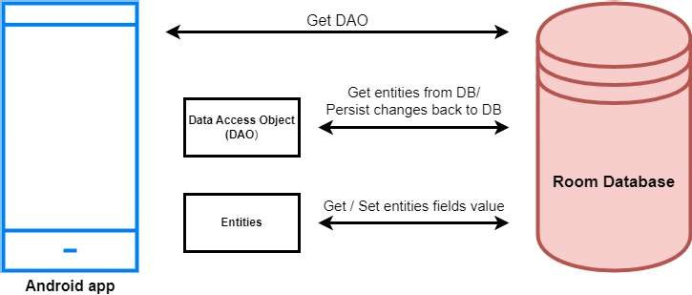**ARCHITECTURE:**

**PROJECT WORKFLOW:**

* **User registration:** Users provide their personal information and create an account to access the study materials.
* **User login:** Once registered, users can log in to the application using their username, email and password to access the study materials.
* **Main page:** After logging in, the user is directed to the main page of the application, where they can access the courses.
* **Study Material:** The user can access the course and they can complete the course based on their interest.

**PROBLEM STATEMENT:**

With growing awareness of the importance of quality sleep for both mental and physical health, there is a need for accessible tools that help individuals monitor and improve their sleep habits. Many existing solutions are either too complex or lack a user-friendly interface that promotes consistent usage. As a result, individuals may not have access to easy-to-understand insights on their sleep patterns, making it challenging to address sleep-related issues effectively. This project aims to address this gap by developing a straightforward and engaging sleep tracking app that provides actionable insights into sleep quality and duration.

**SOLUTION:**

The **Sleep Tracker** app provides a minimalist, easy-to-use platform for users to monitor and improve their sleep habits. Using **Jetpack Compose** for an intuitive UI, the app enables users to start a sleep timer, record their sleep duration, rate their sleep quality, and view daily and historical analyses of their sleep patterns. The app's data visualization offers insights into trends, helping users recognize patterns that may impact their sleep. Future enhancements, such as smart alarms and health metric integration, will make the app a comprehensive solution for those looking to enhance their sleep quality through accessible technology.

**SYSTEM REQUIREMENTS:**

1.HARDWARE REQUIREMENTS:

1. **Development Device (Computer/Laptop):**
   * **Processor**: Intel i5 (8th generation or higher) or AMD Ryzen 5 equivalent
   * **RAM**: 8 GB minimum (16 GB recommended for smoother performance)
   * **Storage**: 100 GB of available storage space
   * **Graphics**: Integrated graphics (discrete GPU optional for emulator acceleration)
2. **Mobile Device for Testing (Optional)**:
   * **Operating System**: Android 8.0 (Oreo) or higher
   * **RAM**: 2 GB minimum
   * **Storage**: At least 50 MB of free storage space for the app

Software Requirements:

1. **Operating System** (for development):
   * Windows 10 or 11 (64-bit), macOS (Big Sur or later), or Linux (Ubuntu 20.04 or later)
2. **Development Tools**:
   * **Android Studio**: Version 4.2 or higher
   * **JDK**: Java Development Kit 11 or higher
   * **Android SDK**: Android SDK API Level 26 or higher
3. **Libraries and Frameworks**:
   * **Android Jetpack Compose**: For building UI components
   * **Room Database**: For local data storage (optional but recommended for sleep data persistence)
   * **Kotlin Coroutines**: For managing asynchronous tasks smoothly
   * **Dagger Hilt**: For dependency injection (optional, for larger app projects)
4. **Database**:
   * **SQLite or Room Database**: For offline data storage and sleep record persistence
   * **SharedPreferences**: For lightweight data (e.g., user settings, last session data)
5. **Additional Tools (Optional)**:
   * **Firebase**: For remote data storage, analytics, and crash reporting (optional)
   * **Git**: For version control and collaboration, with a GitHub or GitLab repository for project storage
   * **Postman**: For testing any APIs (if integrated with other health services)

Testing Requirements:

1. **Android Emulator**: Configured in Android Studio with API Level 26 or higher
2. **Physical Android Device** (optional): For real-world testing, ideally with Android 8.0 (Oreo) or higher

Network Requirements (Optional):

* **Internet Connection**: Required only for features such as updates, analytics, or remote data storage if using Firebase or other cloud services.

**APPLICATION SCREENSHOTS:**

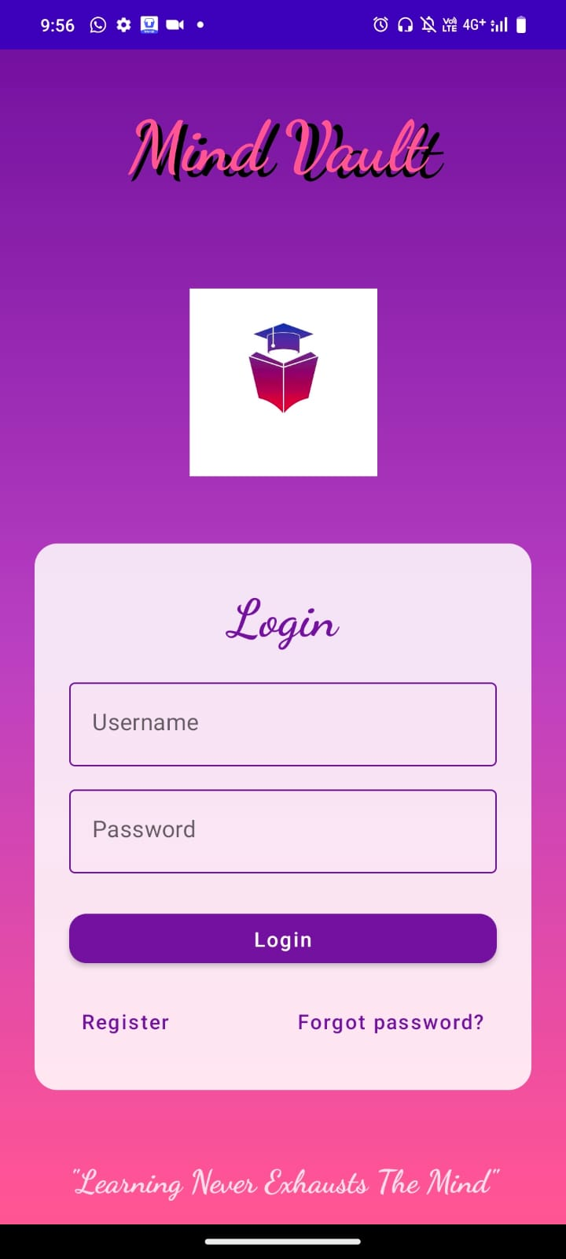 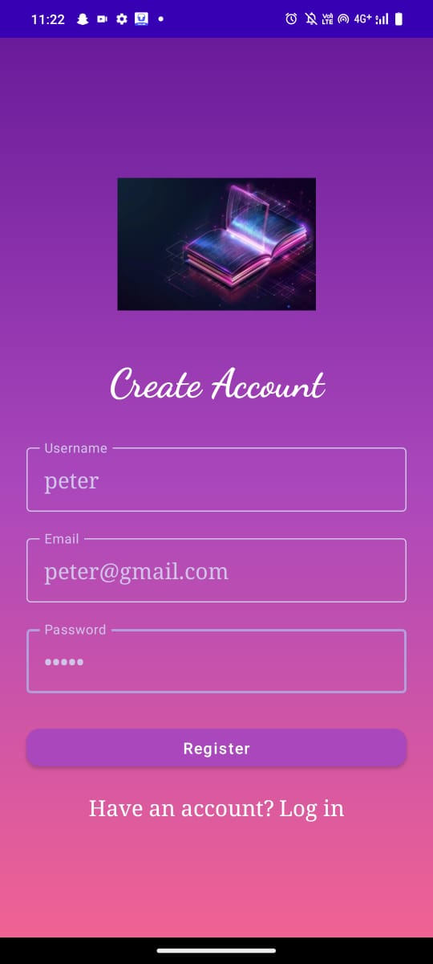

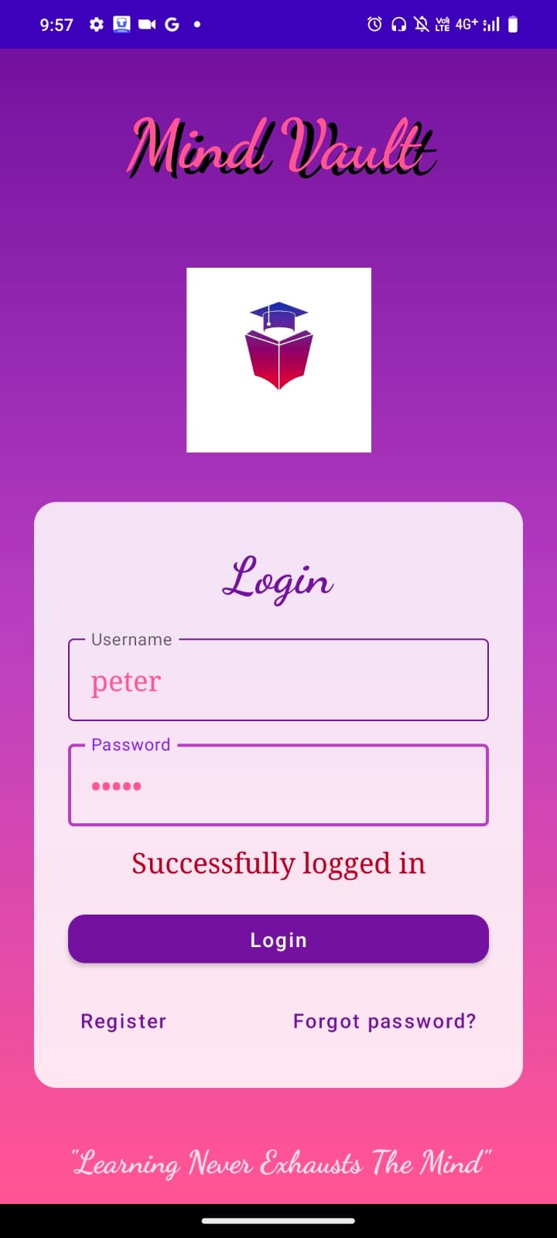 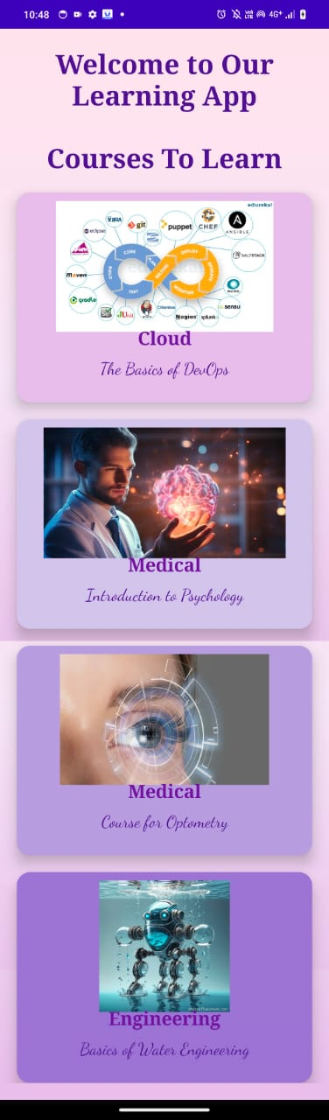

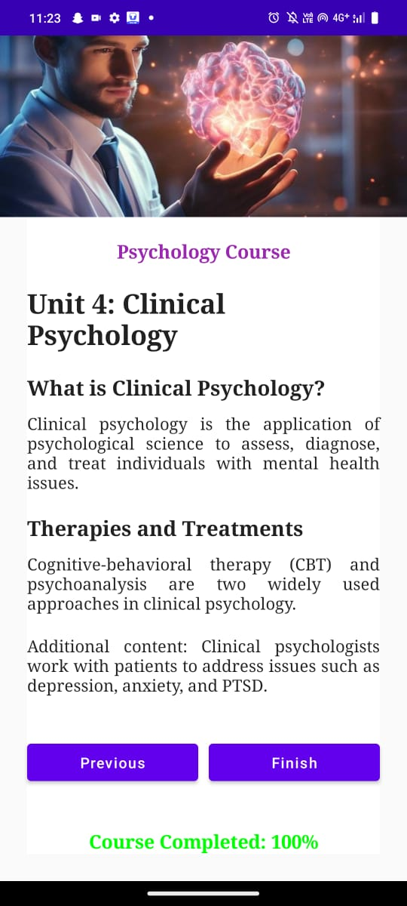

**Applications:**

* + **Improving sleep habits:** By monitoring your sleep patterns, sleep tracking apps can help you identify habits that may be affecting your sleep quality, such as late-night screen time or caffeine intake. This can help you make changes to your routine and improve your sleep quality over time.
  + **Managing sleep disorders:** Sleep tracking apps can help people with sleep disorders such as insomnia monitor their sleep patterns and identify potential triggers for their symptoms. This information can then be shared with a healthcare provider to help develop a treatment plan.
  + **Sports performance:** Sleep tracking apps can also be used by athletes to monitor their sleep quality and quantity. Adequate sleep is essential for physical recovery, and monitoring sleep patterns can help athletes optimize their performance.
  + **Research:** Sleep tracking apps can provide valuable data for sleep researchers studying sleep patterns and habits on a larger scale. By aggregating data from many users, researchers can gain insights into sleep patterns and trends across different populations.

**CONCLUSION :**

Sleep tracking apps have the potential to be useful

tools for improving sleep habits, managing sleep disorders, and optimizing performance in various domains. They can provide valuable data for sleep researchers and help individuals monitor their sleep quality and identify potential triggers for sleep disturbances. In covid pandemic, users prefer to have distant contact with their doctor for sleep issues. Sleep tracking app uses to monitor our sleep and that can helps to taking care of ourselves by using the sleep tracking app.

**FUTURE SCOPE:**

The future of sleep tracking apps looks promising, with continued advancements in technology. Advance sensors can improve the accuracy of sleep tracking apps, capturing more detailed information about sleep patterns. Improved algorithms can better differentiate between light and deep sleep. Sleep tracking apps may provide personalized recommendations based on individual sleep patterns, such as adjusting bedtime, avoiding beverages, or incorporating specific relaxation techniques. Enhanced privacy and security features to protect user data. Gamification elements may motivate users to achieve sleep goals, making it a more fun and engaging experience.

**SOURCE CODE:**